   
If you are a student that **HAS** access to technology, this is not the packet for you. This packet is for students who pick up and drop off their work at the front office every week. If you have access to technology, please go back to your teacher’s website and complete the correct assignment.

Name: _____________­­________________________________ Period: ____________ Teacher: ____________­­­­­________________

**Assignment 4.1 – Alternative Energy Technologies**

Last week, you looked at how carbon footprints have an impact globally in terms of an ecological footprint. Scientists throughout the world have come up with (and continue to discover) many alternative ways to create energy that generate less or no greenhouse gases.

Today, you get to learn a little bit about the creative ways people around the world are working to create a smaller global carbon footprint.

Part I. :

🡪 Use your Textbook (pages 353-355) to write 1 or 2 COMPLETE SENTENCES describing HOW the following processes create energy in California.

*(Textbook pages are provided at the end of this packet)*

1. Nuclear Power: How does nuclear material stored under water in nuclear power plants create electricity?
2. Solar Power: How do solar panels create electricity?
3. Wind Power: How do wind turbines (windmills) turn wind into electricity?
4. Geothermal Power: How does heat below the Earth’s surface use water to create electricity?
5. Hydroelectric Power: How does ocean water waves or river water held back by a dam use the water to create electricity?

Part II. :

Write WHERE you have seen 2 of the Alternative Energy Technologies near YOU!!

1. Type of Alternative Technology You’ve seen from Part I.(above):

Where did you see it?:

1. Type of Alternative Technology You’ve seen from Part I.(above):

Where did you see it?:

**Assignment 4.2 – Decreasing your Carbon Footprint Claim-Evidence-Reasoning**

**Prethink**

*Use what you’ve learned the last 3 weeks about climate change and human activities that lead to increased emissions of greenhouse gases (like CO2 and CH4) to answer the following questions.*

* 1. Review Assignment 3.1: Carbon Footprint from last week and fill in your answers from question 1 into **Data Table 1** “Before Change” column below.
  2. What are three lifestyle choices you *have control over* that you could change to decrease your carbon footprint? (For example: You can’t decrease the number of people in your family no matter how crazy your little sister might be driving you today – but you can choose to walk to school instead of making your hard-working, selfless, loving, wonderful mom drive you).
  3. Pick one of the three choices from above (question 2) that you can commit to. Go back to your results from the carbon footprint activity from last week (also attached at the end of this packet) and fill it out again, this time including the change you’ve decided to make. Fill in **Data Table 1** “After Change” column below with your new results after the change.

**Data Table 1:** Individual Ecological and Carbon Footprint before and after making a lifestyle change.

|  |  |  |
| --- | --- | --- |
|  | Before Change  (From Assignment 3.1) | After Change |
| Ecological Footprint  (number of Earths) |  |  |
| Carbon Footprint  (CO2 emissions in tonnes) |  |  |

**Claim-Evidence-Reasoning (CER): “Did the change you made reduce your carbon footprint?”**

*Please fill in the claim-evidence-reasoning on the next page. As a reminder:*

1. Claim: 1 complete sentence that answers the question.
2. Evidence: Use your data (numbers) from Data Table 1 (above) to support your claim in 1-2 complete sentences.
3. Reasoning: 5-7 complete sentences that tell how your data shows your claim and explains why the change did (or did not) reduce your footprint.

Concepts to include in your reasoning:

* Which numbers were higher – your before or after? And what does that mean in terms of increasing/decreasing your carbon footprint?
* What causes climate change?
* How did (or didn’t) your change decrease carbon emissions (CO2 and CH4)?

**Claim:**

**Evidence:**

**Reasoning:**

**Textbook Pages 353-355**

**Alternative Energy Sources**

As you have observed, the use of fossil fuels has known drawbacks. Not only do they produce pollutants when used, but also extracting them from the ground has potentially damaging effects on ecosystems. In addition, their increased use has resulted in increased levels of carbon dioxide in the atmosphere. Fossil fuels are also nonrenewable and will eventually run out. Scientists, policymakers, and concerned citizens are therefore looking for alternative energy sources, including nuclear power and renewable energy resources. Renewable resources are those that can be replenished as they are used. Such sources include wind, solar, geothermal, water, and biomass.

# Nuclear Power

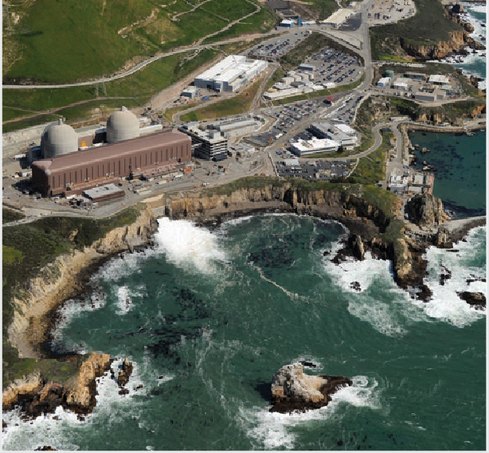

**FIGURE 12:** The Diablo Canyon nuclear power plant in San Luis Obispo County

Most energy-releasing reactions are chemical reactions, which do not affect atomic nuclei. Nuclear reactions involve changes in nuclei, during which small amounts of matter are changed to huge amounts of energy. Just as in a coal power plant, this energy can be used to power steam turbines, so they can generate electrical energy. Although nuclear energy produces no atmospheric pollutants, the processes for mining and refining radioactive materials require large amounts of energy. Nuclear fuel is radioactive, and major concerns surround the disposal of used, or “spent,” nuclear

fuel. These fuels are extremely toxic and are known carcinogens. Their negative impacts on organisms and ecosystems are long-lived and difficult to mitigate.

Accidents at power plants, such as the nuclear disaster at the Fukushima power plant in Japan in 2011, have added to concerns over the safety and reliability of nuclear power solutions.

© Houghton Mifflin Harcourt Publishing Company • Image Credits: ©Mark Ralston/AFP/Getty Images

The dependence on nuclear energy has decreased in California in recent years. It has become a less-desirable energy source as the cost of natural gas and renewable energy sources has dropped and nuclear safety concerns remain. In January of 2018, the California Public Utilities Commission decided to close California’s last nuclear power plant by 2025. This power plant is the Diablo Canyon Power Plant in San Luis Obispo County, shown in Figure 12. The power company itself asked the commission to close it down. Its federal license to operate expires in 2025. The power plant, however, is a major employer, and so the shutdown may not be easy for some.

# Solar Energy

**FIGURE 13:** The Topaz Solar Farm in San Luis Obispo County is a 550-megawatt photovoltaic power station, one of the world’s largest solar farms.

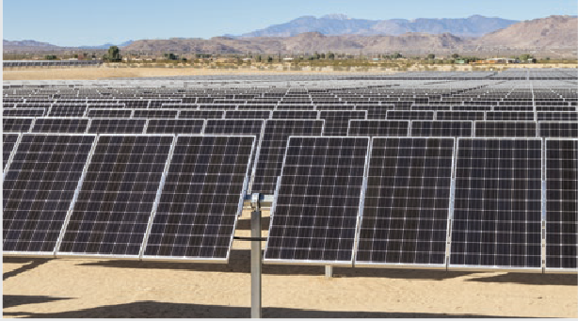Solar energy, which is energy from the sun, can be used to produce electricity. Photovoltaic cells are devices that convert the energy in visible light directly into electrical energy. Photovoltaic cells are connected in panels to produce electricity that may be used at that site. Excess electricity can be sent back to the electrical grid for distribution and use at other locations.

In regions that do have consistent sunlight, huge solar energy “farms” produce energy for entire communities.

25.6 square kilometers of land near the location of the Diablo Canyon nuclear power plant is now covered with a solar energy farm. This is just one of many such

farms that dot the California landscape. At the end of 2016, California was the highest solar-power generating state in the United States, and its capacity for producing solar power is only expected to increase.

# Wind Energy

**FIGURE 14:** The San Gorgonio Pass wind farm is located in the rugged mountains that surround the Los Angeles Basin.

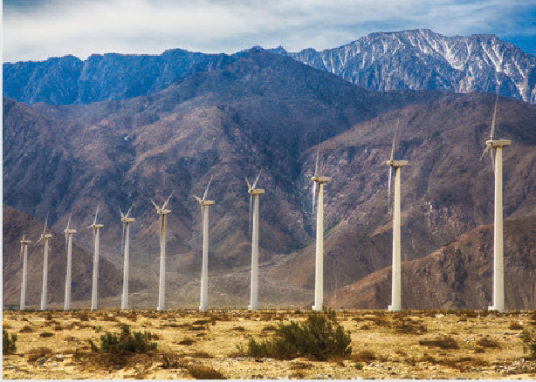Energy from the movement of air in the form of wind can be harnessed to make electricity. Wind generators come in many different sizes. While small windmills produce only a modest amount of electricity, large wind turbines, over 100 m tall, used in groups called wind farms can deliver much more power. They are often situated on hilltops, open plains, shorelines, or in mountain gaps—places that generally experience steady winds. Wind farms need to be in areas with

a minimum annual average wind speed of about

20 km per hour. Of course, the wind speed has to be high enough to turn the blades, but winds that are too strong can damage the blades. When wind speeds are too high, turbines must be shut down temporarily and the blades locked in place.

© Houghton Mifflin Harcourt Publishing Company • Image Credits: (t) ©Tom Grundy/Alamy;

(b) ©Gary C. Tognoni/Shutterstock

While not unusual to see a private windmill providing energy to an individual home or business, most wind energy is commercial. Wind energy accounted for 39 percent of the renewable energy produced in California in 2016. At that time, this was enough electricity to provide power to more than 2 million households in California. More importantly,

the cost of this wind energy was approximately one-fourth of the cost it had been in the 1980s. Most of the wind farms in California are located in Altamont, East San Diego County, Pacheco, Solano, San Gorgonio, and Tehachapi.

**APPLY** Solar and wind energy are both intermittent resources that cannot be relied upon for a constant stream of energy production. Explain why developing better ways to store energy is an important part of making these energy sources more practical to use.

**354 Unit 6** Human Activity and Earth’s Atmosphere

# Geothermal Energy

**Evidence Notebook** California has enacted many laws and regulations to decrease carbon

emissions. Propose another step that could be taken to make energy use safer, more efficient, and/or less harmful to the environment. Which groups of people should be consulted before enacting your proposal? What are some of the tradeoffs you would have to make to enact it?

**Lesson 1** Human Populations and Energy Use **355**

**FIGURE 15:** The Geysers geothermal power plant is the largest producer of geothermal electricity in the world

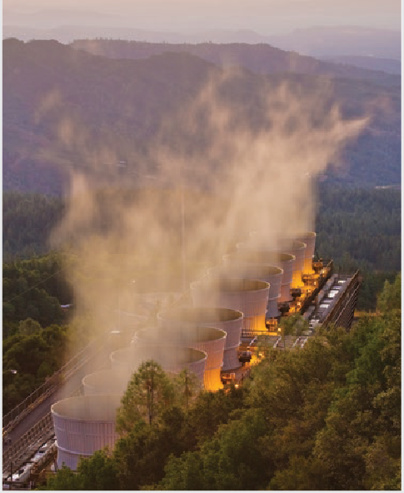Geothermal energy is heat that comes from below Earth’s surface. Similar to the other examples, geothermal energy takes steam from underground sources and uses it to turn a turbine. As an energy source, it is clean, renewable, and produces no greenhouse gases. In addition, unlike the sources of solar energy and wind energy, its source is not variable. If geothermal energy is available at all in a region, it is available consistently. In 2016, geothermal energy provided almost 6 percent of California’s energy needs.

California generates the largest amount of geothermal energy in the United States. After all, California is located on the “ring of fire,” which is the volcanically active region surrounding the Pacific Ocean. Just as magma near Earth’s surface produces volcanoes,

it provides heat in Earth’s crust that can be tapped to provide geothermal energy. California has 25 geothermal resource areas, many of which are used to harness geothermal energy. The largest concentration of geothermal plants is in the Geysers Geothermal Resource Area in Lake and Sonoma Counties. This facility, shown in Figure 15, is located north of San Francisco and has been producing electricity since the 1960s.

# Energy from Water

Hydroelectric energy is electricity that is produced from moving water. The movement of water causes a turbine to spin, which produces electricity that is distributed to the power grid. Electricity can be generated from the movement of river water or ocean water. A major drawback of generating hydroelectric power from a river is the need for a dam.

Dams are expensive to build and change the natural flow of water. Carbon dioxide and methane may also form in the water behind the dam and be emitted into the atmosphere. For these reasons, some dams have been decomissioned. California has more than 250 hydroelectric facilities. Electricity produced by running water and used by California in 2017 totaled nearly 21 percent of the state’s total system power.

© Houghton Mifflin Harcourt Publishing Company • Image Credits: ©Kim Steele/The Image Bank/ Getty Images

Regions like California, which has a long ocean shoreline, are prime candidates for using ocean energy. Although ocean energy can be used in many different ways, the most common forms of usage are tidal power, wave power, and ocean thermal energy conversion. The tidal differences found in California are not large enough to make tidal

power a viable energy source there. California is much more likely to use wave energy as a power source along its Pacific coastline. Wave energy conversion is similar to tidal power in that energy in water movement is harnessed to turn turbines. Wave energy conversion units are installed underwater or on the water’s surface. These may pose threats to boats if they cannot detect them and collide with them.



**Collaborate** Discuss this question with a partner: Why is it important to consider the geography of a place like California when considering developing new energy sources?

